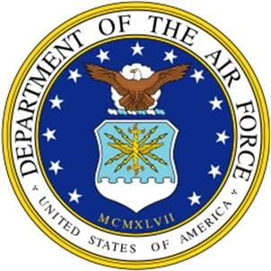 BIOGRAPHY 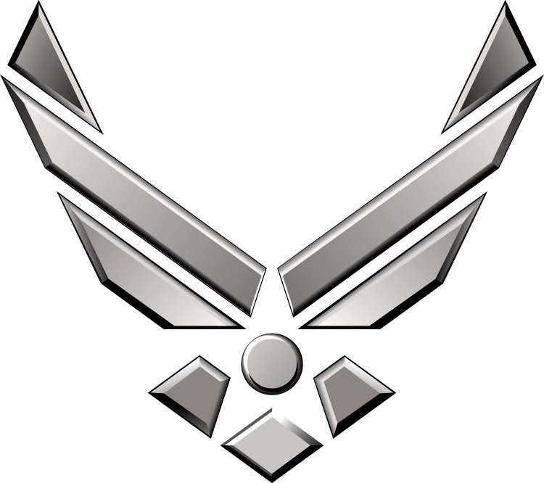
U N I T E D S T A T E S A I R F O R C E

CHIEF MASTER SERGEANT MERISSA K. SCHMIDT
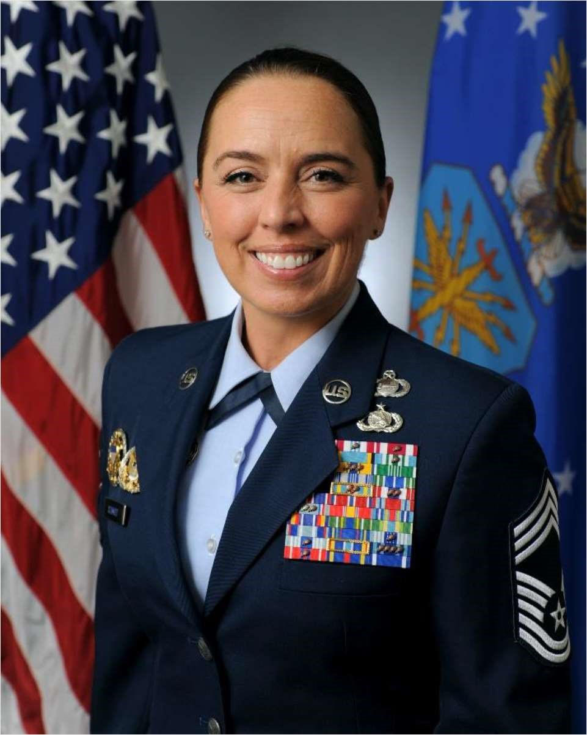
Chief Merissa K. Schmidt is the Senior Enlisted Leader of the 36th Operations Group, 36th Wing, Andersen Air Force Base, Guam. The Group consists of two permanent units and multiple expeditionary squadrons executing U.S. Indo-Pacific Command’s Theater Security Packages and Bomber and Tanker Task Forces from the most forward strategic platform for Indo-Pacific air power projection for the United States and partner nations.

Chief Schmidt grew up in Stockton, Missouri, a small lake town in the Ozarks. She enlisted in the Air Force in May 1998 as a Visual Information Specialist and cross-trained as an All-Source Intelligence Analyst in 2008. She operated at levels of leadership on The Joint Staff, Secretary of the Air Force, Headquarters Air Education and Training Command (HQ AETC), Indo-Pacific Command, Strategic Command (STRATCOM), U.S. Air Forces in Europe (USAFE), Air Force Special Operations Command (AFSOC), and Air Combat Command. She enabled legislative affairs, security cooperation, information warfare, line-haul, aerial refueling, and multi-
national efforts for Operations IRAQI FREEDOM, ODYSSEY DAWN, UNIFIED PROTECTOR, GALLANT PHOENIX, ALLIES REFUGE, and ALLIES WELCOME.

Prior to her current position, she was the Senior Enlisted Leader, Directorate of Intelligence, Sixteenth Air Force (Air Forces Cyber), Joint Base San Antonio-Lackland, TX.
EDUCATION
2002 Bachelor of Science, Business Administration, Wayland Baptist University, San Antonio, TX
- Airman Leadership School, Hickam Air Force Base (AFB), HI
- Associate of Applied Science in Audio-Visual, Community College of the Air Force (CCAF), Maxwell AFB, AL
- Mobility Air Force Intelligence Formal Training Unit, Fort McGuire, NJ
- AF Noncommissioned Officer Academy, Kapaun Air Station, Germany
- Advanced Airlift Mobility Intelligence Course, Rosecrans Air National Guard Base, MO
- Associate of Applied Science in Communications Applications Technology, CCAF, Maxwell AFB, AL
- Basic Combat Convoy Course, Medium, Camp Anderson-Peters, TX
- Master of Arts in International Relations & Conflict Resolution, American Military University, Charles Town, WV
2014 Air Operations Center Intelligence, Surveillance, and Reconnaissance Qualification Course, Hurlburt Field, FL
2016 Senior Enlisted Intelligence Master Skills Course, Goodfellow AFB, TX
2016 AF Senior Noncommissioned Officer Academy (AFSNCOA), Maxwell AFB, AL
2016 AFSOC Air Commando Development Course, Hurlburt Field, FL
2018 Senior Enlisted Joint Professional Military Education II, Fort McNair, Washington, DC, by correspondence
- Joint Special Operations Forces Senior Enlisted Academy, MacDill AFB, FL
- United States Army Sergeants Major Academy, Fort Bliss, TX, by correspondence
- Certificate in Legislative Studies, The Government Affairs Institute at Georgetown University, Washington, DC
- Chief Master Sergeant Leadership Course, Maxwell-Gunter AFB, AL

2023 Group Command Team Course & Senior Enlisted Legal Orientation, Maxwell AFB, AL

ASSIGNMENTS
- May 1998 - June 1998, Basic Trainee, Basic Military Training, Lackland AFB, TX
- June 1998 - October 1998, Student, Defense Information School, Fort George G. Meade, MD
- October 1998 - March 2002, Visual Information Specialist, HQ AETC, Randolph AFB, TX
- April 2002 - March 2006, NCOIC, Image Quality & Utility, Joint Intelligence Center–Pacific, NAS Pearl Harbor, HI
- April 2006 - February 2008, Graphics NCO, National Airborne Operations Center, Offutt AFB, NE
- March 2008 - September 2008, Student, 315th Training Squadron, Goodfellow AFB, TX
- October 2008 - December 2011, Flight Chief, Intelligence Flight, 100th Operations Group, RAF Mildenhall, UK
(Deployed February 2010 - September 2010, S2, 424th Medium Truck Detachment, Joint Logistics Task Force)
- January 2012 - March 2013, Flight Chief, Fusion Team, 11th Intelligence Squadron (11 IS), Hurlburt Field, FL
(September 2012 - December 2012, Superintendent, Detachment 1, 11 IS, Pope Army Airfield, NC)
- March 2013 - January 2014, Intelligence Superintendent, 720th Operations Support Squadron, Hurlburt Field, FL
- February 2014 - February 2015, Flight Chief, Analysis, Correlation, & Fusion, 607 AOC, Osan AB, ROK
- February 2015 – May 2019, Squadron Superintendent, 724th Intelligence Squadron, Pope Army Airfield, NC
(Deployed June 2017 - October 2017, J2 Senior Enlisted Advisor, Combined Joint Interagency Task Force)
- May 2019 – December 2020, Air Force Legislative Fellow, Secretary of Air Force Legislative Liaison, the Pentagon, Washington, DC
(August 2019 – December 2019, Defense Legislative Fellow, USSOCOM Office of Legislative Affairs, Washington, DC)
(January 2020 – December 2020, Defense Legislative Fellow, Office of Senator Cramer, Capitol Hill, Washington, DC)
- January 2021 – January 2022, Deputy Legislative Assistant to the CJCS, Legislative Affairs, Office of the
Chairman of the Joint Chiefs of Staff, the Pentagon, Washington, DC
- January 2022 – May 2023, Senior Enlisted Leader, Directorate for Intelligence, Sixteenth Air Force (Air Forces
Cyber), Joint Base San Antonio-Lackland, TX
- June 2023 – Present, Senior Enlisted Leader, 36th Operations Group, Andersen Air Force Base, Guam

MAJOR AWARDS AND DECORATIONS
Defense Meritorious Service Medal with two oak leaf clusters
Meritorious Service Medal with two oak leaf clusters
Aerial Achievement Medal
Joint Service Commendation Medal with oak leaf cluster
Air & Space Commendation Medal with three oak leaf clusters
Army Commendation Medal
Air & Space Achievement Medal
Army Achievement Medal

OTHER ACHIEVEMENTS
2000 Senior Airman Below-the-Zone, Randolph AFB, TX
2002 Distinguished Graduate, Airman Leadership School, Hickam AFB, HI
2008 Distinguished Graduate, Operations Intelligence Apprentice Course, Goodfellow AFB, TX
2011 USAFE Intelligence, Surveillance, & Reconnaissance (ISR) Noncommissioned Officer of the Year
2014 Seventh Air Force ISR Senior Noncommissioned Officer of the Year
- 607th Air Operations Center Senior Noncommissioned Officer of the Year
- 724th Special Tactics Group Senior Noncommissioned Officer of the Year
- & 2017 AFSOC ISR Squadron of the Year
- AFSNCOA Chief Master Sergeant Richard L. Etchberger Team Award
- AFSOC ISR Senior Noncommissioned Officer of the Year
- Distinguished Honor Graduate, Joint Special Operations Forces Senior Enlisted Academy, MacDill AFB, FL

EFFECTIVE DATE OF PROMOTION
Chief Master Sergeant 1 September 2020

(Current as of June 2023)

